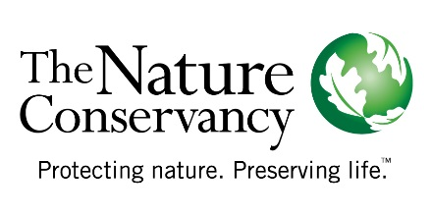

A Partnership between Yale University and The Nature Conservancy, Wyoming Chapter for a Summer Fellowship
Overarching Question: How can we balance regional flow needs downstream with local wetland wildlife needs? Can we optimize the location and timing of different irrigation practices to meet the needs of both?
Project Idea: Investigate the feasibility of a developing a scenario analysis tool for the Popo Agie Watershed that would highlight the potential tradeoffs between the flow benefits of demand management programs (e.g., rotational fallowing of fields across single or multiple irrigation districts) or water-use efficiency projects (center pivots, ditch upgrades) and potential wetland/wildlife impacts. Student will work closely with TNC staff, potential end users and TNC partners working in the Popo Agie Watershed to identify needs and data availability.
Outcome: Produce a report outlining the feasibility of developing a scenario analysis tool for the Popo Agie Watershed. Identify most appropriate models, available datasets, what data would need to be developed, and what the tool design could look like (e.g. GIS-based, web-based, maps?) to be most effective with end-users and provide site specific information to guide management decisions.
Background: Scenario analysis tools are often used to test the effects of different assumptions about the way the future could unfold and the implications for the system being modelled. Scenario analysis tools do not help produce a forecast, or prediction of the future; instead, they provide a more robust way of thinking about the future through consideration of multiple feasible alternative futures (Dong et al., 2012). Such tools offer approaches to model and balance water demands with supply (quantity and quality) that account for administrative control and management (water regulations/laws and infrastructure) without compromising ecosystem sustainability. Scenario analysis tools have been adopted as a management technology to articulate mental models about the future and to explore future uncertainties in a coherent, consistent, and plausible way (Yoe, 2004). Scenario development for water resource planning and management helps decision makers to understand the implications of the uncertainty and explore the future water availability (surface water, groundwater storage, water quality) and water demand conditions and, as a result, design and make robust management strategies or policies to achieve planning objectives (e.g., alleviating water stress, improving water quality, maintaining the ecosystem service, etc.). The underlying idea is that scenarios display alternative future states of the water system and facilitate informed decisions and management strategies.
We need a particular type of scenario analysis tool to support our work with agricultural communities to improve water-use efficiency and/or reduce consumptive use. Specifically, we need site-specific tools that quantify and highlight potential tradeoffs between the flow benefits of demand management programs (e.g., rotational fallowing of fields across single or multiple irrigation districts) or water-use efficiency projects (center pivots, ditch upgrades) and potential wetland/wildlife impacts. Ideally, these tools would utilize historic wetlands information and site-specific wildlife data to inform choices in project design. Results would identify how projects might make decisions that leave water available for wildlife seasonally (i.e. during migration), while providing added flows. The most cost-effective technical solution will differ according to the project’s particular circumstances. For some projects, a set of relatively simple guidelines may be sufficient. For others, it may be appropriate to use a decision support system (for example, see Holmquist-Johnson et al. 2016).

